***Project Phase IV Report***

***On­­­***

**Transport Optimization Program**

**Submitted for the requirement of**

**Project course**

BACHELOR OF ENGINEERING

**COMPUTER SCIENCE & ENGINEERING**



**Submitted to: Submitted By:**

**Project Teacher (Supervisor) Harshit Gupta 20BCS4925**

**ROHINI BAWA (E12228) Kinshuk Chauhan 20BCS4917**

**Ankul Agnihotri 20BCS4913**

**Ashutosh Kumar 20BCS4960**

**Sohail Iqrar 20BCS7814**



**Co Supervisor Signature**

**GURSIMRAN KAUR (E7544)**

**DEPARTMENT OF COMPUTER SCIENCE & ENGINEERING**

**CHANDIGARH UNIVERSITY, GHARUAN**

**June 2022**

### 

**ABSTRACT**

TOP [Transport optimization program]'s main purpose is to optimize the transportation system. Optimization includes the method to use resources efficiently like transportation system so that it saves time and even makes it available on time for passengers and also to reduce pollution, and conserve energy. Sharing of the vehicle is Vehicle pooling so that multiple numbers of people can travel in a single-vehicle. the use of vehicle pooling reduces single individuals Travelling costs, reduces the fuel cost, and reduces the number of vehicles. Due to the growth in the population, there is inadequate transportation through their vehicle. Rather than using a different mode of Transportation. It results in an increasing amount of traffic on roads also increases pollution and increases the time to travel to their destination. So, by Smart transportation using a vehicle pooling system the individual can travel and share their rides with different people of the same destination. In this paper, we have carried out a survey. Reviewing various Literature papers on carpooling it aims to reduce the number of vehicles by sharing the rides. Electric taxis have the potential to improve urban air quality and save drivers’ energy expenditure. Consequently, the running cost of EVs comes to Rs 1 per km, Rs 9 for petrol, Rs 6 for diesel, and about Rs 2.5 per km for vehicles being run on CNG. Although 3 battery electric vehicles (BEVs) have drawbacks such as the limited range and charging inconvenience, 4 technological progresses has been presenting the promising potential for electric taxis Its website and mobile apps connect drivers and passengers willing to travel together between cities and share the cost of the journey[1]. The company does not own any vehicles; it is a broker and receives a commission (between 18% and 21%) from every booking. In this era of technology, everything is getting combined with technology to perform or transform for the better so we will be using technology to make an effort to solve this problem.[2] We will be building a website that will be a platform that will connect the passengers with the traveling mode.

**TABLE OF CONTENT**

|  |  |  |  |  |  |  |  |  |  |  |  |  |  |  |  |  |  |  |
| --- | --- | --- | --- | --- | --- | --- | --- | --- | --- | --- | --- | --- | --- | --- | --- | --- | --- | --- |
|  | | |  |  |  | | --- | --- | --- | | **S.NO.** | **CONTENT** | **PAGE NO.** | | 1. | Use of Modern tools in design and analysis |  | | 2. | Discussion and report/results analysis |  | | 3. | Project management and Professional communication (Presentation) |  | | 4. | Attainment of stated outcomes |  | |  |
|  | |  |  |
|  | References | |  |

**USE OF MODERN TOOLS IN DESIGN AND ANALYSIS:**

The tools used in the projects are mentioned below: -

HTML 5:

HTML stands for Hyper Text Markup Language. It is used to design web pages using a markup language. HTML is the combination of Hypertext and Markup language. Hypertext defines the link between the web pages. A markup language is used to define the text document within tag which defines the structure of web pages. This language is used to annotate (at the note for computer) text so that a machine can understand it and manipulate text accordingly. Most of the markup (e.g. HTML) languages are human readable. The language uses tags to define what manipulation has to be done on the text. It is used for structuring and presenting the content on the web pages. HTML5 is the fifth version of HTML. Many elements are removed or modified from HTML5.

Advantages of using HTML 5 are, It supports audio and video controls with the use of and tags It uses SQL databases and application cache to store offline data. Allows JavaScript to run in background. This is possible due to JS Web worker API in HTML5.Vector graphics is additionally an integral a part of HTML5 like SVG and canvas. It allows drag and drop effects. HTML5 allows to draw shapes like circle, rectangle, triangle etc. It supported by all new browser like Firefox, Mozilla, Chrome, Safari, etc.HTML5 language is more mobile-friendly. Doctype declaration is quite simple and easy. New element for web structure like nav, header, footer etc. Character encoding is simple and easy. One can track the Geolocation of a user easily by using JS geolocation API. It is capable of handling inaccurate syntax. Attributes of charset, async and ping are a part of HTML 5.

CSS:

Cascading Style Sheets (CSS) is a stylesheet language used to describe the presentation of a document written in HTML or XML (including XML dialects such as SVG, MathML or XHTML). CSS describes how elements should be rendered on screen, on paper, in speech, or on other media.

CSS is among the core languages of the open web and is standardized across Web browsers according to W3C specifications .You might have heard about CSS1, CSS2.1, CSS3. However, CSS4 has never become an official version.

Advantages of CSS3, the scope of the specification increased significantly and the progress on different CSS modules started to differ so much, that it became more effective to develop and release recommendations separately per module. Instead of versioning the CSS specification, W3C now periodically takes a snapshot of the latest stable state of the CSS specification.

JavaScript:

JS, is a programming language that is one of the core technologies of the World Wide Web, alongside HTML and CSS. Over 97% of websites use JavaScript on the client side for web page behavior, often incorporating third-party libraries. All major web browsers have a dedicated JavaScript engine to execute the code on users' devices. JavaScript is a high-level, often just-in-time compiled language that conforms to the ECMAScript standard. It has dynamic typing, prototype-based object-orientation, and first-class functions. It is multi-paradigm, supporting event-driven, functional, and imperative programming styles. It has application programming interfaces (APIs) for working with text, dates, regular expressions, standard data structures, and the Document Object Model (DOM). The ECMAScript standard does not include any input/output (I/O), such as networking, storage, or graphics facilities. In practice, the web browser or other runtime system provides JavaScript APIs for I/O. Advantages of JS are: -

* Speed. Client-side JavaScript is very fast because it can be run immediately within the client-side browser. Unless outside resources are required, JavaScript is unhindered by network calls to a backend server.
* Simplicity. JavaScript is relatively simple to learn and implement.
* Popularity. JavaScript is used everywhere on the web.
* Interoperability. JavaScript plays nicely with other languages and can be used in a huge variety of applications.
* Server Load. Being client-side reduces the demand on the website server.
* Gives the ability to create rich interfaces.

Node.js:

Node.js is a cross-platform, open-source back-end JavaScript runtime environment that uses the V8 engine to execute JavaScript code outside of a web browser.

Node.js excels in creating fast, scalable network applications, with performance, development speed, and other advantages. Node.js allows developers to utilize JavaScript to create command-line tools and server-side scripting, which involves running scripts on the server before sending the page to the user's browser. As a result, Node.js symbolizes a "JavaScript everywhere" paradigm, bringing web-application development together around a single programming language rather than separate languages for server-side and client-side scripts.

Node.js has the following advantages:

When you utilize Node.js for the backend, you get all of the benefits of full stack JavaScript development, including

* better efficiency and overall developer productivity
* code sharing and reuse
* speed and performance
* easy knowledge sharing within a team
* a huge number of free tools

Express.JS:

Express.Js is one of the best backend development JavaScript Framework. The primary usage of it is creating Restful API’s what accept request from frontend and send the appropriate response.

Actually Express.js is a JavaScript library and with the help of it, we can build a backend. First, start an NPM project, install Express package, create models, routes, etc. A simple backend server is ready.

Why Express.js:

A lot of alternatives are there like Laravel, Django, Ruby on Rails, etc. But why you should choose Express.js?

* You only need to learn one language for both frontend and backend development, which is JavaScript. To develop a web frontend, HTML, CSS, and JS is needed. So, JavaScript is necessary and the same language is used to code backend if it’s Express.js.
* The support of Node.js is one of the best reasons because of which Express.js is preferred. So that an Express.js backend can be developed with the support of all the NPM packages that make the process easier.
* You would be able to debug your application faster than ever with the help of the debugging mechanism it offers to its users. This helps to find error points easily without taking much time.

EJS:

EJS simply stands for Embedded JavaScript. It is a simple templating language/engine that lets its user generate HTML with plain JavaScript. It offers an easier way to interpolate (concatenate) strings effectively.

Why EJS?

Now while there are several templating systems out there with their merits and demerits, I personally use EJS because of its simplicity in syntax and logic. It's also very easy to set up.

### MongoDB:

MongoDB is an open-source document database built on a horizontal scale-out architecture that uses a flexible schema for storing data. Founded in 2007, MongoDB has a worldwide following in the developer community.

Instead of storing data in tables of rows or columns like SQL Database, each record in a MongoDB database is a document described in BSON, a binary representation of the data. Applications can then retrieve this information in a JSON format.

## Why Use MongoDB?

MongoDB is built on a scale-out architecture that has become popular with developers of all kinds for developing scalable applications with evolving data schemas.

As a document database, MongoDB makes it easy for developers to store structured or unstructured data. It uses a JSON-like format to store documents.

MONGOOSE :

Mongoose acts as a front end to MongoDB, an open-source NoSQL database that uses a document-oriented data model. A "collection" of "documents" in a MongoDB database is analogous to a "table" of "rows" in a relational database.

Why and advantages of Mongoose:

1. The syntax between the Node Driver and the Mongo shell is very similar and so you'll get a quicker grasp of how to use MongoDB in general.
2. Models are only useful when you are scaling into a big application with a large API that needs to be broken up into a **M**VC system (mongoose being your models).

**DISCUSSION AND REPORT/RESULT ANALYSIS:**

Our project, based upon Web Application about future of transportation with random people(carpooling). In this there is serious reduction of number of vehicles on the road which leads to lessen the effects of emission of pollution related gases carbon dioxide, monoxide just to name a few.

This project is to create a platform to solve major environmental issues and to provide customers with optimized facilities. This is going to prove a good approach to resolving the issues related to costly cab booking and also save the time of the customers. This will also have several good effects like a better use of resources and a reduction in time incompatibility.

Our project is unique in itself, and it’s having own features. The uniqueness of our project can be measured by considering many factors like our objectives which is to provide anyone the best way to travel to their destination, the features that we will be providing to our customers, reliability of the project, and application of the project.

Trade growth of goods and services and the upsurge in activities are generally high in cities of developing countries. Every city needs to enhance its transport infrastructure to cope with the increase in transportation demand. In addition, these transportation infrastructures need to be efficiently used in order to minimize costs and maximize output. Adopting sharing-based business models can help in increasing the trade of goods and services and can increase the number of activities.

**Design Selection**

1. **Application overview table:**

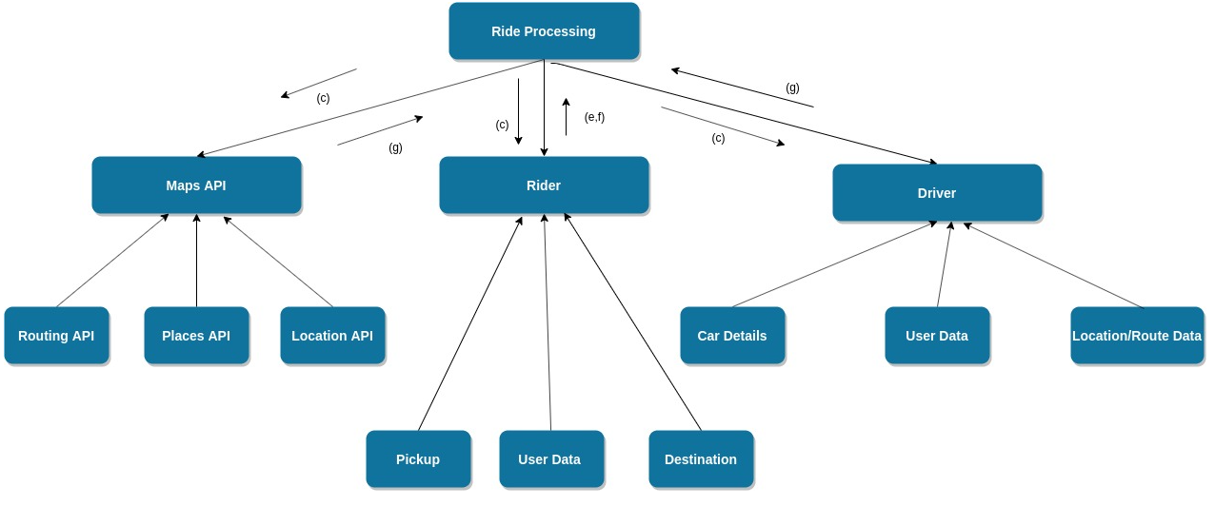

1. **Data flow diagram:**

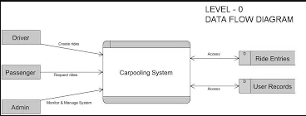

1. **Use Case Diagram:**

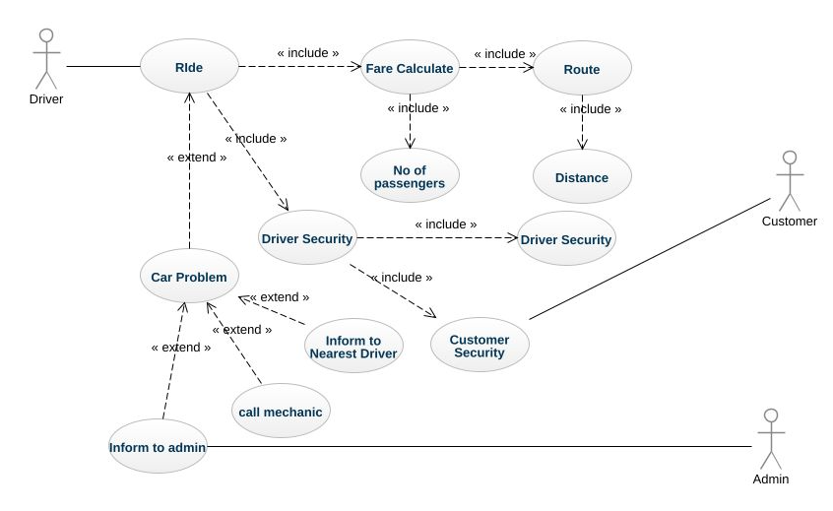

**(FRONT-END)**

**Home Page:**

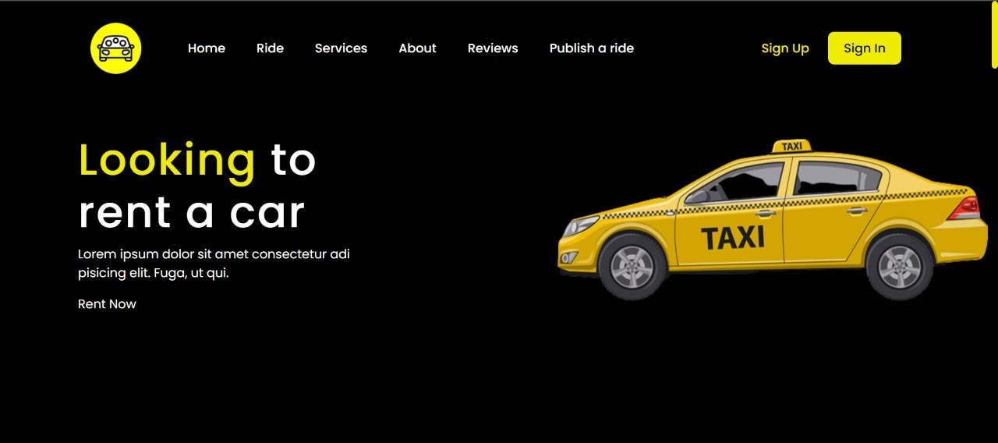



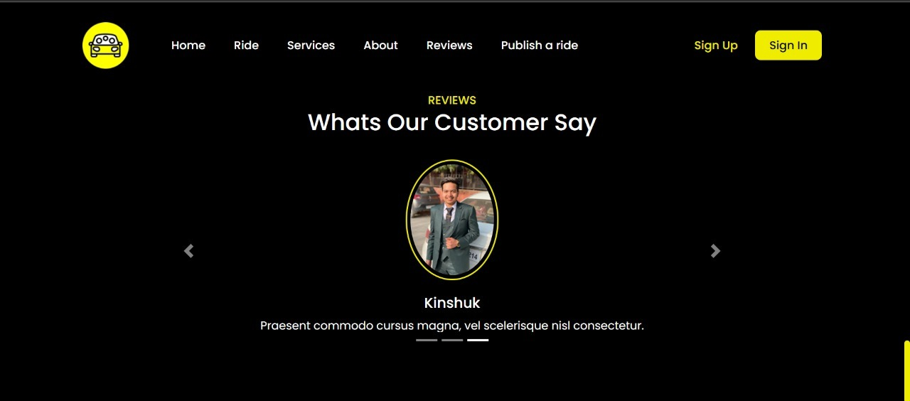

**Register Page:**

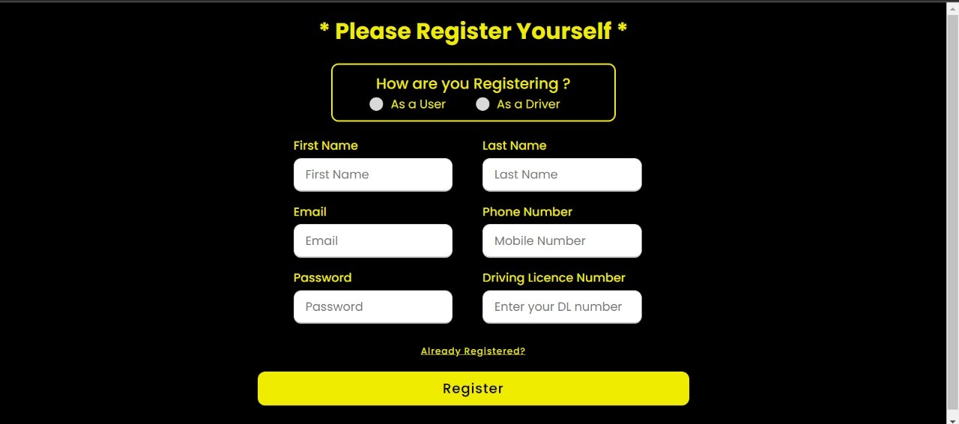

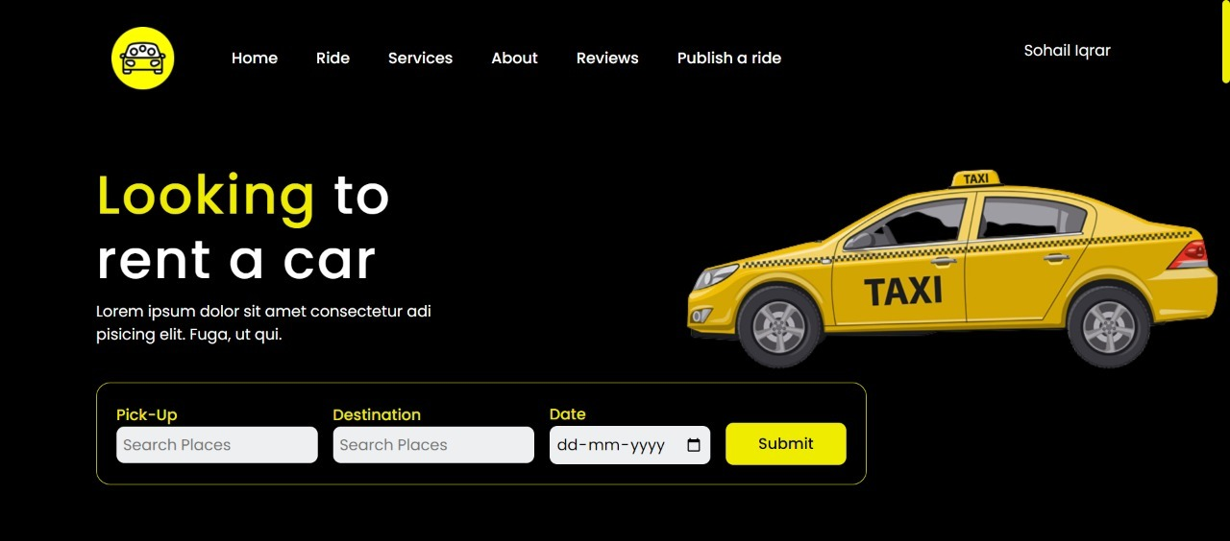

**Ride Details:**



**(BACK-END)**

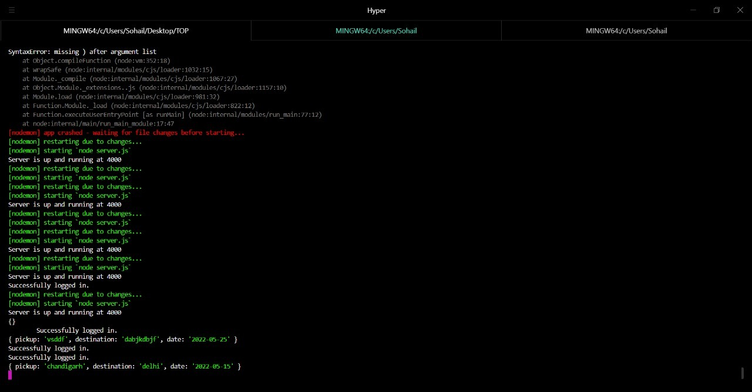

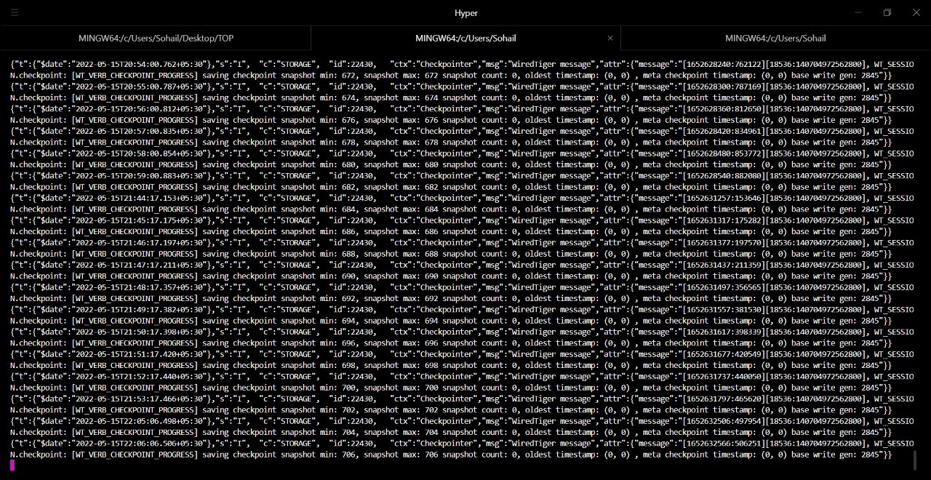

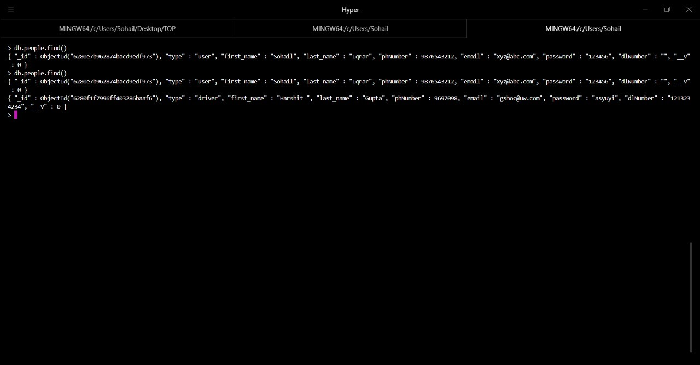

**ATTAINMENT OF STATED OUTCOMES :**

Promote sustained, inclusive and sustainable economic growth, full and productive employment and decent work for all.

**Reference:**

[1]Hanif and Sagar (2016). The cab services are proving security through a global positioning system (GPS) and women taxi drivers for women passengers, especially during night times.

[2]Horsu and Yeboah (2015), have argued that driver behavior has a negative impact on cab services at Ghana

**\*\*\*\*\*\*\*\*\*\*\*\*\*\*\*\*\*\*THANKYOU\*\*\*\*\*\*\*\*\*\*\*\*\*\*\*\*\***